***Supplementary Material***

**Thermometry of Plasmonic Nanostructures by Anti-Stokes Electronic Raman Scattering**

## Xu Xie1*, David G. Cahill 1*

*1Department of Materials Science and Engineering, Materials Research Laboratory, University of Illinois at Urbana-Champaign, Urbana, Illinois 61801, USA.*

\**To whom correspondence should be addressed. *(X.X.) E-mail:* [*xuxie1@illinois.edu*](mailto:xuxie1@illinois.edu) *(D.G.C.)* [*d-cahill@illinois.edu*](mailto:d-cahill@illinois.edu)

**Fabrication of plasmonic nanodisks.** We used the ‘hole-mask colloidal lithography’ technique to fabricate Au nanodisks on quartz substrates.31 Supplementary Fig. S1 shows a schematic of the fabrication process. We started by spin-coating (4000 r.p.m, 60 s) a sacrificial layer of poly(methyl methacrylate) (PMMA, MicroChem 495 A5) onto pre-cleaned (sonication in acetone and isopropanol alcohol for 5 min, respectively) double-side-polished crystalline quartz substrates (ST-cut, Hoffman Materials). Baking the PMMA at 170 ˚C in air for 10 min dried the solvent, and a short period (10 s) of oxygen plasma treatment (200 mTorr, 100 W, March RIE) improved the surface hydrophilicity. Drop-casting a water solution of poly(diallyldimethylammonium chloride (PDDA, Sigma Aldrich, 0.2 wt%) onto the PMMA followed by rinsing in water provided a positively charged surface. A water suspension of well-dispersed polystyrene beads (Bangs laboratories, with carboxylic acid group) was subsequently applied for 4 min, during which the negatively charged beads attached evenly on the surface due to electrostatic interactions. Rinsing in water again followed by nitrogen gun blowing removed unattached beads and dried the surface. We deposited 5 nm Ti and 35 nm Cu (e-beam evaporation) on the substrate as an etch mask. Sonication of the substrate in IPA for 2 min removed the polystyrene beads and exposed the PMMA area underneath. Reactive ion etching (RIE, 200 mTorr, 100 W, 5 min) was used to etch through the PMMA resist. E-beam evaporation of Au (with 5 Å Ti adhesion layer) followed by lift-off formed nanodisks on the quartz substrate. We finished the fabrication by UV-ozone treatment of the sample (20 min) to remove PMMA and other hydrocarbon residues, and depositing a capping layer of dielectrics (e-beam evaporated SiO2 or atomic layer deposition of Al2O3).

**Measurement of electronic Raman scattering.** A Ti-Sapphire laser (Tsunami, cw mode, 785 nm) was used to excite the plasmonic nanodisks. Two bandpass filters (Semrock) at 785 nm ± 1 nm are used to remove background fluorescence from the laser beam. For the excitation of multiple nanodisks, a 10× objective lens (Leica) focused the beam onto the top surface of the sample with a 1/e2 radius of ≈5.1 μm. The sample was glued onto a temperature controlled stage (Linkam Scientific) with surface temperature calibrated by a Pt resistor (1kΩ, Omega Engineering). For individual nanodisk experiments, a 50× objective lens (Leica) focused the laser onto the sample fixed on a three-dimensional (3D) linear piezo-stage (Physical Instrument, Q-545.240, close-loop operation, 6 nm minimal incremental motion and 18 nm unidirectional repeatability). The 1/e2 radius of the focused laser beam was measured as ≈1.1 μm by TDTR off-set beam measurements.41 The scattered light, after passing through the objective lens and two short pass filters (785 nm, Semrock), was focused by another lens to the slit of the spectrometer (Andor Shamorock 163, with a 300 lines/mm grating). The integration time for data acquisition was typically 200 s.

**Calculation of the temperature rise for an individual nanodisk.** We used both analytical and finite element method (FEM) approaches to calculate the temperature rise.

Analytically, the temperature rise of the substrate was first calculated by solving the steady-states heat transfer equation in a semi-infinite space using cylindrical coordinates,

 (S1)

where Λ is the thermal conductivity of the quartz substrate. The boundary conditions involves a uniform, circular heat flux on the top surface , and zero heat flux for the infinite bottom surface. , where *P* is the power of the laser beam, *W0* is the 1/e2 radius, *H(D/2-r)* is a Heaviside function, D is the diameter of the nanodisk, is the absorption cross-section and is the physical cross-section. Hankel transformation of *Equ.1* and the boundary conditions allows obtaining the solution in *k* space. The *r* space temperature profile is the inverse Hankel transformation of the solution,

 (S2)

where J0 and J1 is the zero and first order Bessel function.

To calculate the temperature rise of the Au nanodisk, we averaged  within the area of the nanodisk, and added the temperature drop between the Au and quartz substrate due to interfacial thermal resistance. The overall temperature rise is

 (S3)

, where *Gint* is the interfacial thermal conductance.

For FEM simulation, we used commercialized software COMSOL (three dimensional heat transfer module). A heat flux of *ft* was added on the top surface of the Au nanodisk. The heat transported through an artificial interface (with interfacial thermal conductance *G*int), and dissipated into the substrate with a domain size of 50×50 µm2. All surfaces were set as thermal insulation except the bottom of the substrate, which was kept as constant temperature.

**Measurement of the key parameters for temperature calculation.** Several important parameters, such as D, **,** Λ and Gint were measured experimentally. Scanning electron microscopy (SEM, Hitachi 4800) determined the diameters of the Au nanodisks. Optical absorption was directly measured by an UV-vis-NIR spectrometer (Agilent Cary 5000) with an integrating sphere detector. The sample was placed in the center of the integrating sphere during measurements. Normalization of the optical absorption by the number of disks per unit area measured by SEM yielded. An ultrafast-laser-based pump-probe thermal measurement, time-domain thermoreflectance (TDTR), was used to obtain the thermal conductivity of the quartz substrate. The measurement involved using a pump beam to heat the quartz surface covered with a thin layer of Al transducer (via sputtering deposition), and a probe beam to monitor the temperature change via the change of thermoreflectance. Λ can be extracted by incorporating the measured results into a layered heat diffusion model with Λ as the only unknown parameter.

Similarly, we used the transient attenuation measurement to determine Gint. The pump beam consisting of a train of sub-picosecond pulses heated the Au nanodisk sample. The probe beam measured the temperature rise via detecting the attenuation of the optical transmission in a time-resolved manner. We extracted Gint by fitting the measured results with a thermal model using *G*int as the only adjustable parameter.

All relevant parameters, including their values and uncertainties, are listed in Supplementary Table 1 (Table S1). To evaluate the total uncertainty in the calculated temperature rise, we add the uncertainties that propagate from the uncertainty of each parameter listed in Table S1. Specifically, the total uncertainty is , where is the uncertainty of each parameter xi.

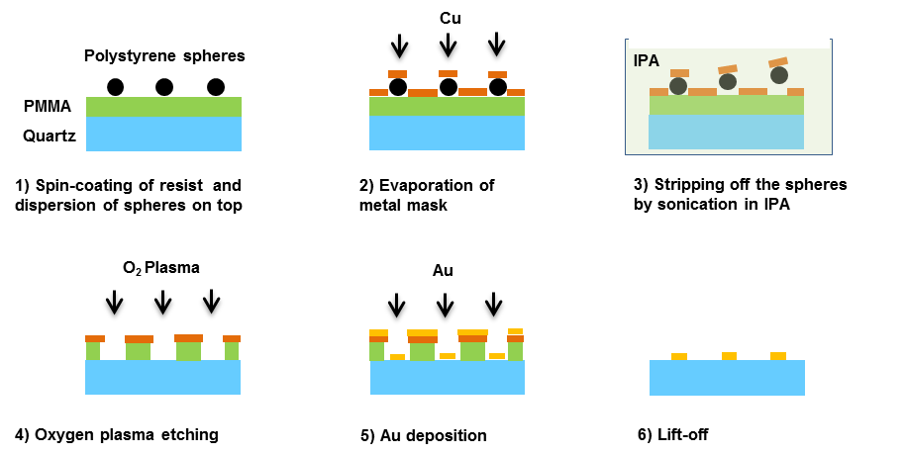

**Supplementary Figure S1.** Schematic illustration of the fabrication process for Au plasmonic nanodisks on a quartz substrate.

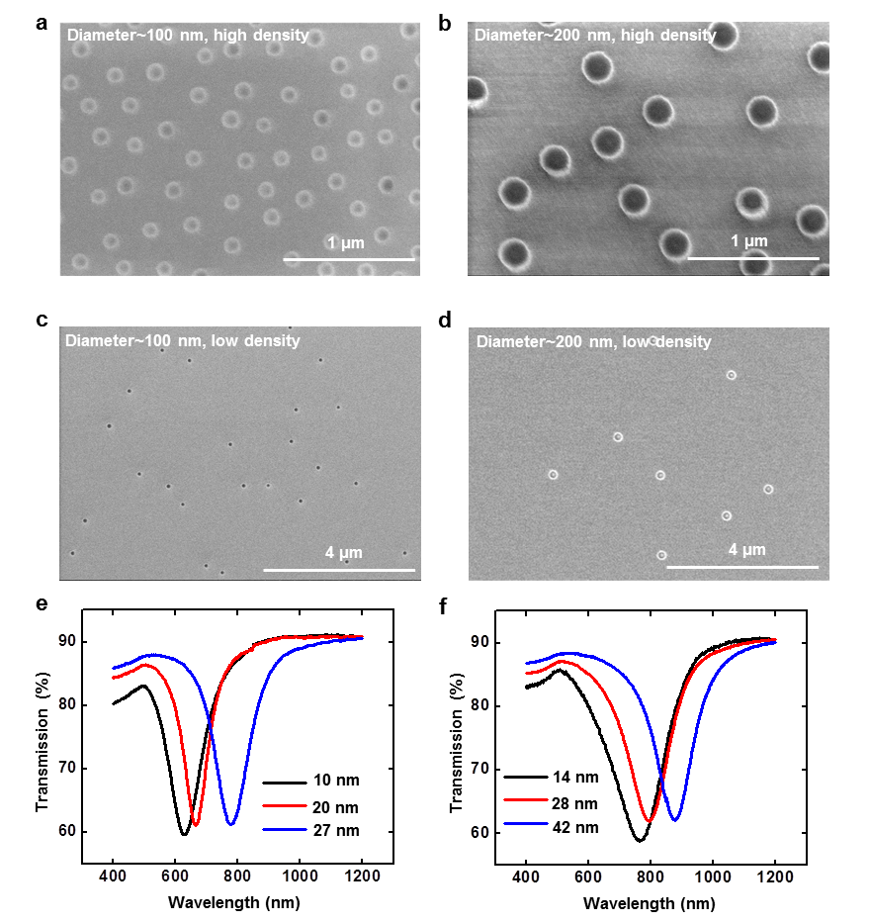

**Supplementary Figure S2.** (a)-(d) SEM images of nanodisks with different diameters and densities: (a), (b) high density nanodisks with nominal diameters of 100 nm and 200 nm, respectively. (c), (d) low density nanodisks with nominal diameters of 100 nm and 200 nm, respectively. (e) Transmission spectra of nanodisks (100 nm diameter) with heights at 10 nm, 20 nm and 27 nm. (f) Transmission spectra of nanodisks (200 nm diameter) with heights at 14 nm, 28 nm and 42 nm. The resonance wavelength red-shifts as the diameter of the disk increases and the height decreases.

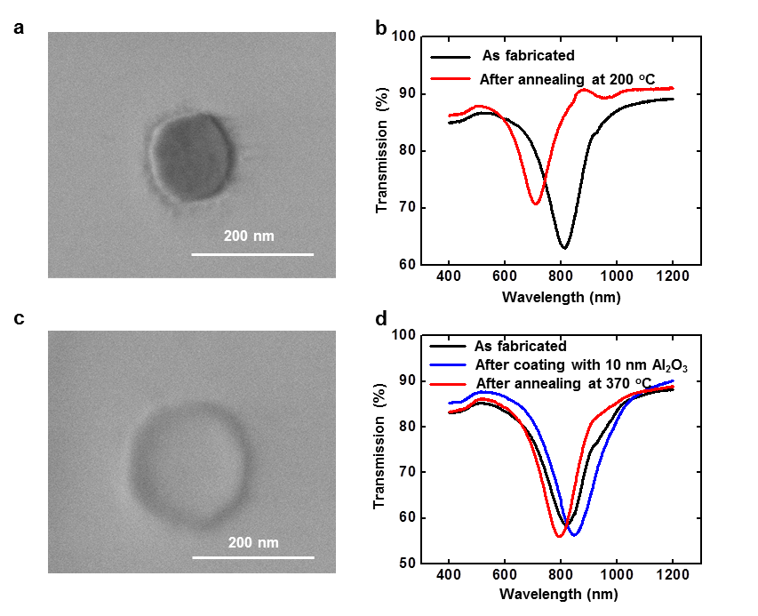

**Supplementary Figure S3.** (a) SEM image of an Au nanodisk on quartz substrate annealed at 200 oC for 15 min. A decrease in size is clearly observed. (b) Transmission spectra of as-fabricated nanodisks (black curve) and the same sample after being annealed at 200 oC (red curve). (c) SEM image of an Au nanodisk on quartz substrate covered with 10 nm Al2O3 (deposited by atomic layer deposition). The disk were annealed at 370 oC for 15 min. (d) Transmission spectra of as-fabricated nanodisks (black curve), nanodisks coated with Al2O3 (blue curve) and the ones annealed at 370 oC (red curve).

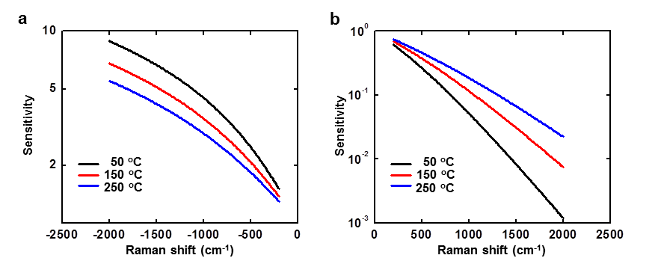

**Supplementary Figure S4.** (a) Sensitivity of the normalized spectral intensity of the anti-Stokes Raman scattering regarding the temperature of Au nanodisks, i.e. at different Raman shift. The sensitivity is higher for small temperature excursion and wavenumber. As a result, fitting Eq. 2 at low Raman shift reduces the systematic errors. However, the experimental uncertainties increase due to the increase of noises associated with data at small Raman shift. In practice, we chose the lower limit of Raman shift in considerations of both fitting sensitivity and data noise. (b) Sensitivity of the normalized spectral intensity of the Stokes Raman scattering at various temperatures. The sensitivity is much smaller than that of the anti-Stokes Raman scattering.

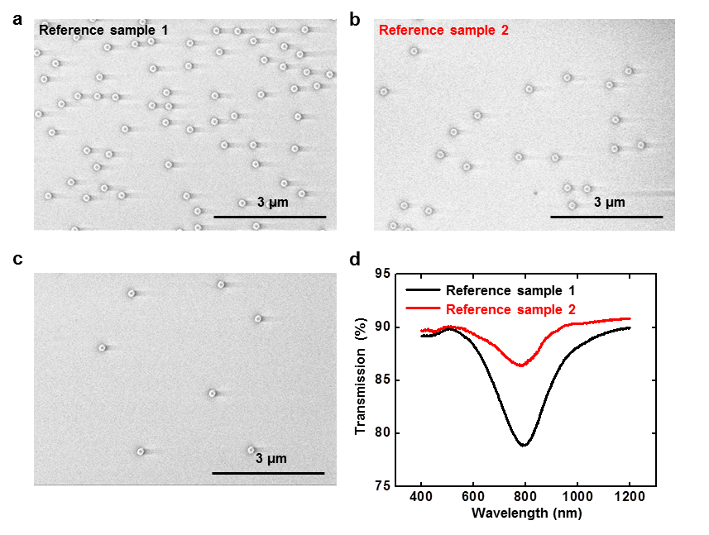

**Supplementary Figure S5.** Due to the large noise presenting in the extinction spectrum (for the sample with sparse disks), two additional reference samples with higher nanodisk density were prepared from the same batch for confirming the resonance. (a), (b) SEM images of reference samples used for confirming the plasmonic resonance of the sample with low density. (c) SEM image of the sample with low-density nanodisks. The sample is used for studying the anti-Stokes Raman thermometry at individual nanodisk level. It is prepared from the same batch with the references. (d) Transmission spectra of the reference samples, showing the resonant wavelength at around 790 nm.

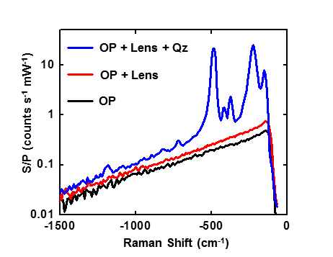

**Supplementary Figure S6.** Constitution of background signals for the anti-Stokes Raman scattering spectrum of individual nanodisk: overall background signals (blue curve), with contributions from the fluorescence of quartz substrate (Qz), objective lens (Lens) and the rest of the optics (OP); background taken by removing the quartz substrate (red curve); background collected without the quartz substrate and the objective lens (black curve).

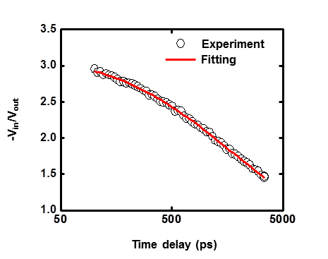

**Supplementary Figure S7.** Raw data (black circles) and fitting (red curve) of TDTR measurement of a sample consisting of Al (79 nm) / crystal quartz (500 µm thick, ST cut, cutting angle 42o45’). The extracted thermal conductivity of quartz is Λ = 7.9 ± 0.7 W m-1 K-1.

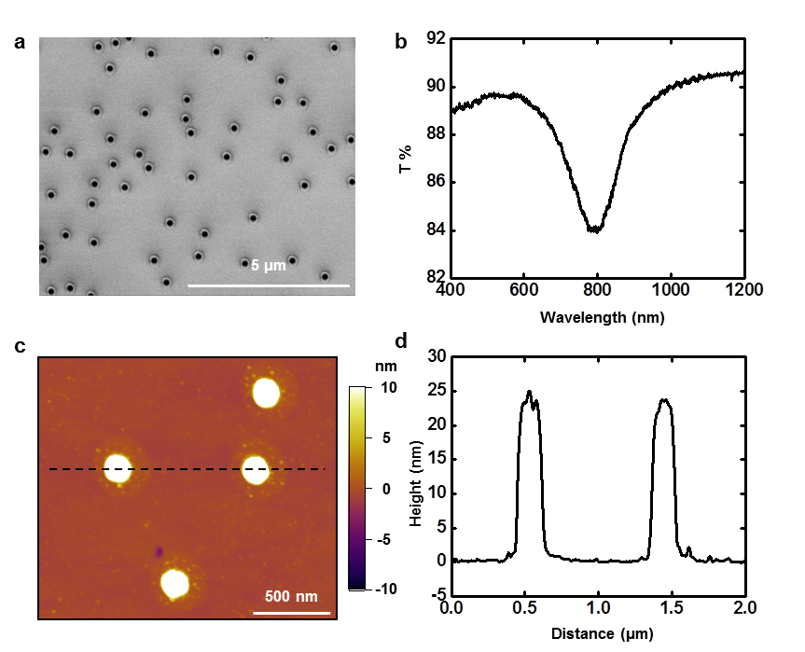

**Supplementary Figure S8.** (a) SEM image of the sample used for extraction of interfacial thermal conductance by transient absorption measurement. (b) Transmission spectrum of the sample. (c) AFM topography image of the sample. (d) Height profile along the black dashed line in (c), showing that the height of the disks is h = 23 ± 2 nm.

**Table S1.** Values and errors for the parameters used in temperature calculation.

|  |  |
| --- | --- |
| Parameters | Values and Errors |
| Laser power (P) | 1 mW ± 0.05 mW |
| Laser spot size (W0) | 1.1 µm ± 0.05 µm |
| Lens transmission (T) | 82 % ± 2 % |
| Nanodisk diameter (D) | 174 nm ± 20 nm |
| Absorption cross-section (σabs) | 0.024 µm2 ± 0.005 µm2 |
| Quartz thermal conductivity (Λ) | 7.9 W m-1 K-1 ± 0.7 W m-1 K-1 |
| Interfacial thermal conductance (Gint) | 100 MW m-2 K-1 ± 20 MW m-2 K-1 |